Science Notes
Class-VII
Chapter 4-Heat
Give reasons for each of the following
Ans-a) Ventilators are made near the ceilings of a room because the air we breathe out is warmer. It rises and goes out through ventilators.Cool and fresh air enters the room through windows and doors which are much below than the ventilators.
Ans -b)A metal spoon becomes hot when placed in a hot cup of tea because of conduction process.
Ans-c) Handles of cooking utensils are made of wood because they are bad conductor of heat.
Ans -d)Room heaters have polished reflectors at the back of the heating element because it helps to direct all the heat from the heating coil towards the front of the heater.
Ans -e)Cooking utensils are made of aluminum because aluminum is good conductor of heat,so that heat gets transferred to the food that has to be cooked easily .
Ans –f) The base of cooking utensils are black in colour because they absorb more heat energy and cook food in less time.
Ans-g)freezers are placed at the top of refrigerator because the cold air produced from it is denser than the warmer air in the bottom .So cold air being dense sinks down and the warm air is forced to rise up so when the warm air rises up it gets cold in the freezer due to convection current of air.
Ans-h)We prefer wearing dark colored clothes in winters because they absorb more heat of the sun and to keep our body warmer.
Very short answer type Question
Ans-a) Thermometer
Ans-b) 37⁰C and 98⁰F
Ans-c) A maximum and minimum thermometer is used to measure the maximum and minimum atmospheric temperatures of a day.
Ans-d)Joule
Ans-e) Wood, plastic, rubber etc.
Short Answers type Questions
Ans1) Mercury is used in thermometer for the following reasons
- It remains in the liquid state for a wide range of temperature.
- It is easy to see because it has a silver-grey colour.
- It does not stick to the glass.
- It has a fairly uniform rate of expansion for a wide range of temperature.
Ans2) C =5/9(F-32)
=5/9(48-32)
= 5/9 X 16
=80/9
=8.88◦ C
Ans3) Conduction is the process of transfer of heat from the hotter to the colder end of the body or between two bodies at different temperatures which are in contact with each other.
Conduction occurs when the molecules at the hotter end of an object acquire energy and vibrate. The vibrations are passed along the object and thus heat is transferred to its other end.
Ans4 ) Radiation is the process of transfer of heat which does not require any medium .In this process the heat is transmitted from a hot body in all directions without the help of inter mediate particles. By the process of radiation heat can also be transferred through vacuum.
Ans5 ) Clinical thermometer is used to measure the body temperature of human beings. There is a constriction or kink in the tube near the bulb which ensures that the mercury in the bulb before the temperature is read .It ensures that the user takes the correct reading of temperature.

Long Answer type Questions-

Ans1) Precautions while using a thermometer
1-Handle it carefully as it can break easily.
2-Always wash the thermometer before and after use.
3-Always make sure that mercury is below the mark of normal temperature before use.
4- Read the temperature by keeping the thermometer at the eye level.
5-Do not hold the thermometer by the bulb.
Ans2 ) Heat is the mode of energy that get transferred from hotter object to colder object. Heat can be transferred from one body to another by three modes
- Conduction- Conduction is the process of transfer of heat from the hotter to the colder end of the body or between two bodies at different temperatures which are in contact with each other. Conduction occurs when the molecules at the hotter end of an object acquire energy and vibrate. The vibrations are passed along the object and thus heat is transferred to its other end.
2) Convection-The process of transfer heat in liquid and gases from the hotter part of a substance to the colder part by the actual movement of particle is called convection. For example when we mix hot water in cold water, the mixed water becomes warm . The molecules of hot water move to cold water and heat it up.
3) Radiation- Radiation is the process of transfer of heat which does not require any medium .In this process the heat is transmitted from a hot body in all directions without the help of inter mediate particles. By the process of radiation heat can also be transferred through vacuum.
Ans3) Applications of convection-
1-Ventilators are made near the ceiling of a room because the air we breathe out is warmer. It rises and goes out through the ventilators.
2-Heaters and blowers used to heat up a room should be placed near the ground level so that they heat the entire room by setting up convection currents.
3-Firemen crawl while entering a building on fire because hot air and smoke ae least near the ground.
4-Sea breeze and land breeze occur due to convection currents.
5-Air conditioners used to cool rooms should be placed at higher level as cold air is heavy and will come down and cool the room.
Ans 4)A thermos flask does not allow the loss of heat by the material stored in it .All three modes of heat transfer are minimized inside it.
The outer casing of thermos flask is made up of an insulating material like plastic that minimizes the heat loss due to conduction.
Heat loss due to convection is minimized in the inner jar, made of double glass or stainless steel
due to the vacuum present between them.
The inner surface of the jar is highly reflective; this minimizes the heat loss due to radiation. The heat radiations are reflected back into the jar
.
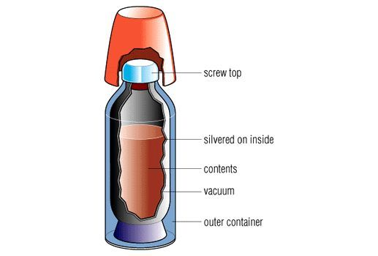
Thermos flask
Distinguish Between
Ans1)
Land breeze | Sea breeze
1-It blows from land to sea  2-It blows during night  3-It is also called off shore breeze  4-It is caused by decrease in land temperature | It blows from sea to land  It blows during day time  It is also called on shore breeze  It is caused by increase in land temperature

Ans2) 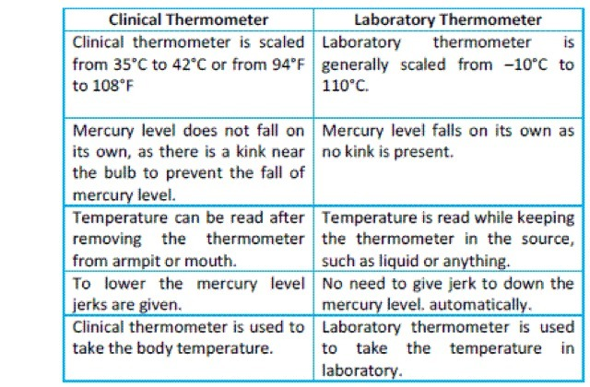

Ans3)
Conduction | Convection | Radiation
1-The transfer of heat from hotter region to the colder region such that there is no actual movement of the particles of the medium | The transfer of heat by the movement of the particles from hotter region to colder region | The transfer of heat directly from hotter region to colder region with out any intervening medium.
2- It occurs in solids | It occurs in liquids and gases | Solid ,liquid and gas can all be heated by radiation
3-It require medium | It require medium | It does not require any  medium
4.It is not possible in vacuum | .It is not possible in vacuum | .It is possible in vacuum.
5.This process is slow | This process is faster than conduction | This process is the fastest.

Extra question-1 –Difference between Heat and temperature

Heat | Temperature
1)It is a form of energy | It is the degree of hotness or coldness of a body.
2)It is the phenomenon which helps in raising the temperature of an object. | It is the effect of heat
It is measured in joules | It is measured in degree Celsius, degree Fahrenheit or Kelvin scales.

#####@#####

